2.0 Improvements to EwE software

2.1 Geospatial projection of model area
The Ecospace module of the (EwE) software applies the ecological dynamics of a marine food web across a grid of cells. Traditionally, this grid is geo-referenced to decimal degrees longitude [-180, 180] and latitude [-90, 90], where cells taper at higher latitude ranges – the common WGS84 or EPSG:4326 projection. In its functional groups dispersal calculations Ecospace automatically takes this into account.
For the 2017 Coastal Master Plan community model these calculations need to be modified to enable environmental driver data input to Ecospace to be mapped to a local UTM spatial projection with highest positional accuracy.
Re-projecting the UTM data to the traditional Ecospace projection would cause irrevocable changes to driver data since UTM grid cells do not perfectly align nor perfectly overlap with the Ecospace grid. Driver data would thus not arrive in its accurate form in Ecospace, which was deemed unacceptable for the development of the 2017 Coastal Master Plan community model. It was thus opted to extend Ecospace with the ability to incorporate this data.

2.1.1 Changes to EwE
The following changes have been made to the EwE software to satisfy this requirement in three aspects of the EwE source code:
- The Ecospace model has gained an “Assume square cells” flag. When this flag is turned off, Ecospace will operate in traditional fashion assuming cell tapering by latitude, and assumes that cell coordinates and dimensions are specified in decimal degrees. When turned on, Ecospace assumes that its grid is geo-referenced to a relatively small local area where cells can be considered square, and cells coordinates and dimensions are specified in meters. This required changes to the EwE database format, and changes to Ecospace dispersal computations and sailing cost calculations, which both perform key distance calculations that need to take different geo-spatial projections into account.
- The Ecospace user interface has been adjusted to correctly translate between cell size (stated in projection units) and cell length (stated in km, used for functional group dispersal purposes).
- Ecospace data import and export routines have been adjusted to use the correct map projection units.

2.1.2 Using the new developments
Users can toggle the square cells flag in the “Edit Basemap” form, found in the Ecospace menu, where map units and the cell length / cell size translations change with the value of the “Assume Square Cells” flag (Figure 2.1). The Ecospace map provides correct location feedback to the mouse cursor when hovering over the Ecospace map (Figure 2.2).
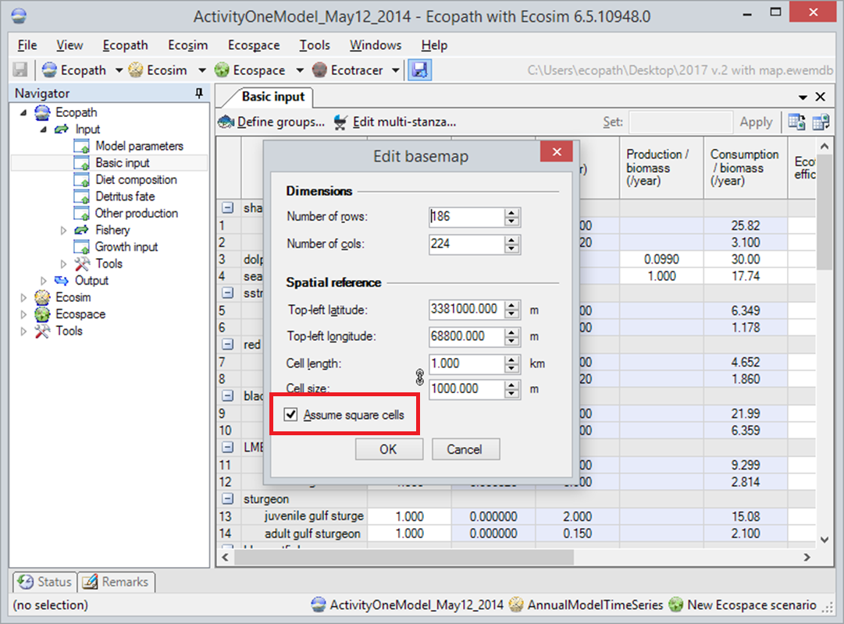
Figure 2.1 – Toggling the “Assume Square Cells” setting to switch between WGS84 / EPSG:4326 projections (when the setting is turned off) and a local UTM projection (when the setting is turned on).

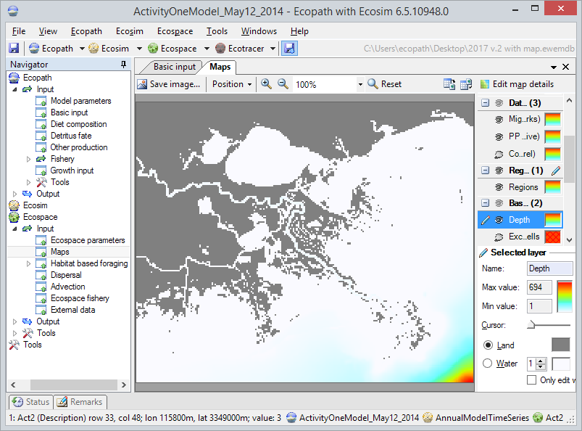
Figure 2.2 – The Ecospace map interface providing geo-spatial location feedback for a local UTM grid in the EwE status bar, at the bottom left.

2.2 Excluding map cells
Historically, users could only exclude Ecospace map cells from computations by turning these cells to land. This would yield confusing maps with unrecognizable land contours. In response, the concept of excluded cells was introduced to the Ecospace model in EwE release 6.4:,cells that do not contain ecosystem dynamics, that are not considered in the Ecospace computations, and that are not rendered in the map displays.
This feature allows accurate display of irregular (e.g., non-square) maps. During the development of the 2017 Coastal Master Plan community model the feature was used extensively but created confusion during model calibration and testing stages since it was sometimes not explicitly clear whether cells were empty due to misconfiguration of the model or due to excluded cells.
It was decided to add a feature that could be toggled to explicitly display which cells were excluded.

2.2.1 Changes to EwE
The following changes have been made to the EwE software to satisfy this requirement in two aspects of the EwE source code:
- The EwE user interface has gained the means to toggle display of excluded cells in a few locations.
- When this option is turned on, the Ecospace input and output maps will always explictly indicate which map cells are excluded.

2.2.2 Using the new developments
Users can toggle the ‘Always show excluded cells’ flag in the “Maps” form of the EwE options interface, found in the main menu (Figure 2.3), as well as in the excluded cell editor in the Ecospace input maps interface (Figure 2.4). The Ecospace input and output maps provide correct visual feedback (Figure 2.5 and Figure 2.6).
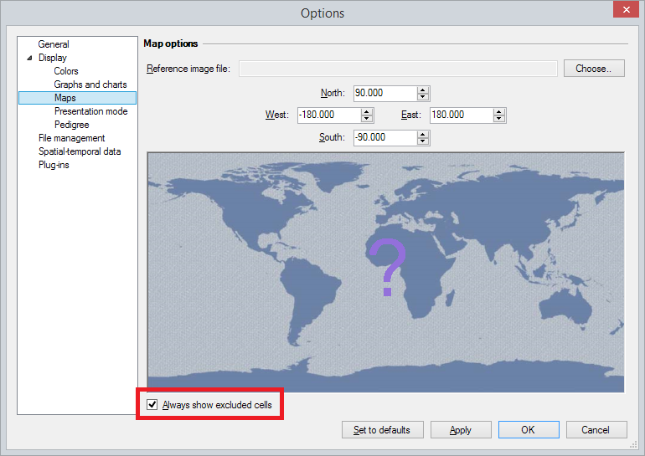
Figure 2.3 - Toggling the excluded cells option in the EwE options interface

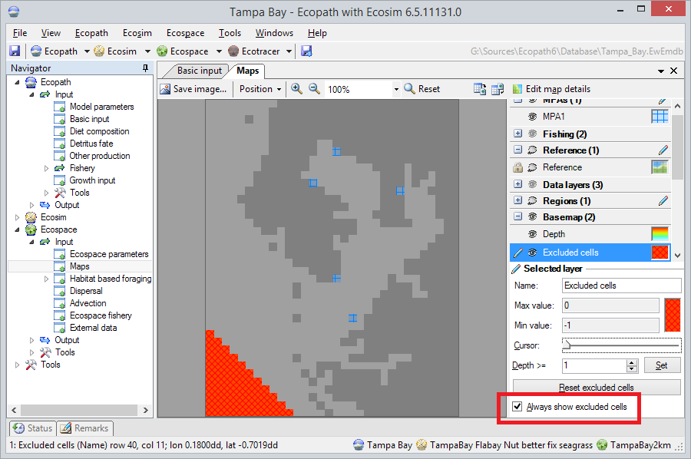
Figure 2.4 - Toggling the excluded cells option in the EwE maps interface. The toggle is located in the Excluded Cell editor panel (bottom right), while the Ecospace map is showing excluded cells (the bright red area, bottom left, in the map)

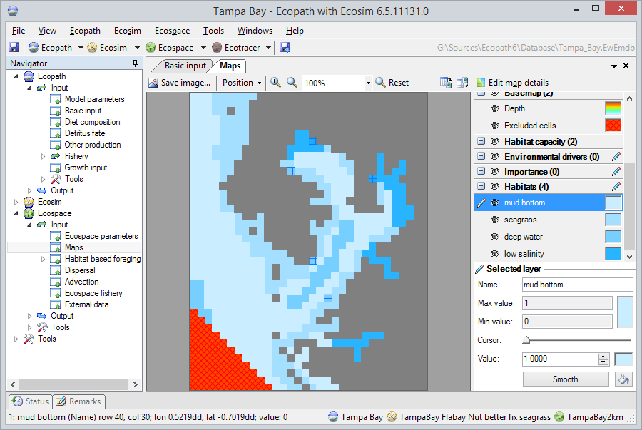
Figure 2.5 - The Ecospace map input interface responding to the 'Always show excluded cells' setting. Excluded cells are rendered in bright red (bottom left triagnle of the map)

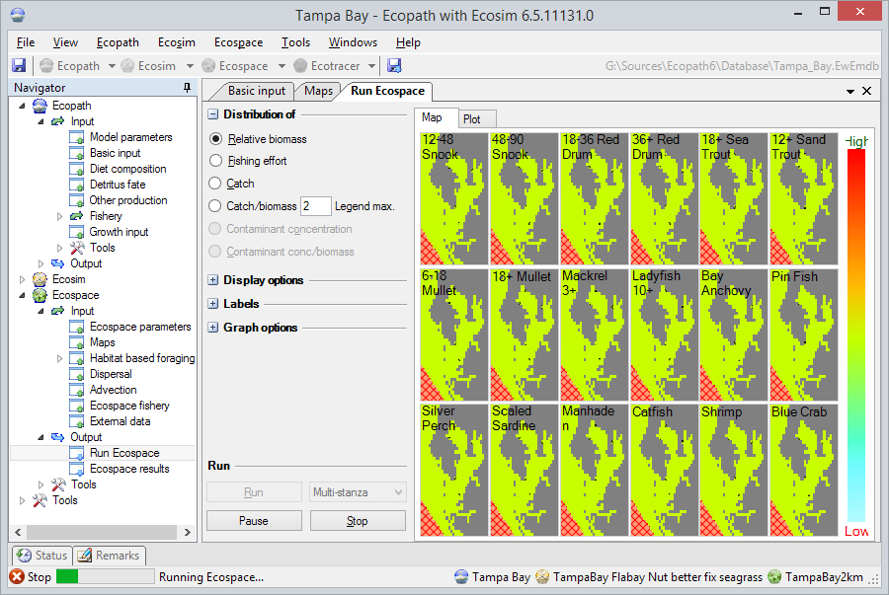
Figure 2.6 - The Ecospace results maps interface responding to the 'Always show excluded cells' setting (bottom-right area of each map)

2.3 Sharing external spatial datasets between computers
The Ecospace module of the Ecopath with Ecosim (EwE) software recently gained capabilities to be driven by external spatial-temporal datasets, a feature that would be extensively used for the 2017 Coastal Master Plan community model. These external data sets cannot be embedded within a EwE model because they tend to be model-derived datasets that frequently update, and that are of prohibitive file size. The process of connecting to these data is detailed in Steenbeek et al. (2013).
Since the 2017 Coastal Master Plan community modeling exercise would be executed by scientists of different institutes in different locations, this system needed to be extended to offer support for shared use of the same modelwith accompanying external spatial data via cloud-based transfer media..

2.3.1 Changes to EwE
The Ecospace model stores definitions of available spatial-temporal data series in a local configuration file (Steenbeek et al., 2013). Sharing this configuration file is Impractical when a local system contains dataset definitions for a suite of Ecospace models: support was needed to only selectively share relevant data for a given modeling exercise. To enable this, the following changes have been made to the EwE6 software:
- An export function was added to EwE6 that allows a user to copy a selection of dataset definitions to a local folder with a local configuration file. Whereas datasets on a local system are indicated by absolute file paths, the exported datasets refer to their files via local paths, making this export folder highly suitable for transfer to another computer.
- An option has been added to allow users to switch to another configuration file – either locally created configuration files particular to a given modeling exercise, or shared configuration files obtained via a cloud-based file transfer system - which will provide Ecospace with access to the external spatial-temporal data connections described in the configuration file.
EwE6 model databases already carried all information needed to connect an Ecospace layer to external data sets (Steenbeek 2013). However, this information just contained technical details internal to the model, and was too sparse to assist troubleshooting when expected data sets could not be located. The following changes have been made to the EwE6 software:
- EwE6 model databases now also store the configuration of data sets, but not the actual data due to its prohibitive size.
- When Ecospace loads this information it tries to resolve these data sets. If a local computer does not know these data sets, the data sets are instantiated from the data stored in the model, and the user is warned that the data set may be incomplete. Having access to the complete configuration information, a user can figure out what external data is needed to reassemble the model configuration by requesting a data set export from the original model author, and then linking to these data.

2.3.2 Using the new developments
Users can export data sets from several locations in EwE, such as the main Ecospace menu and the interface where external datasets are defined (Figure 2.7).
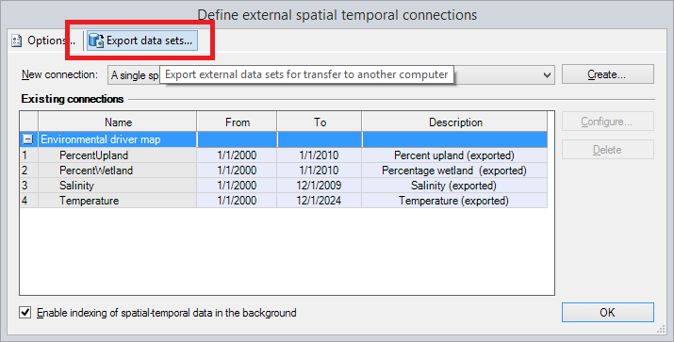
Figure 2.7 - Where to find the "Export data sets" option

When this option is selected a dedicated interface is displayed. Here users can decide which data sets to export for transfer to another computer, such as all data sets or only those used by the current model (Figure 2.8). Note that this interface is still in its infancy and may need further work to allow users to select an export directory, to display export progress, and to display export result information.
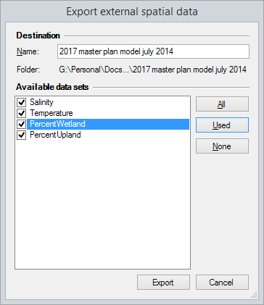
Figure 2.8 - Data set export interface

The EwE6 status panel notifies the user where where the data sets have been exported to. When clicking this link, users are brought to the export directory which in its entirety can be transferred to another computer, or can be shared via a cloud-based service such as Dropbox. The Export folder contains directories with file content for individual data sets where applicable, and a “ewe_datasets.xml” configuration file for these files (Figure 2.9).
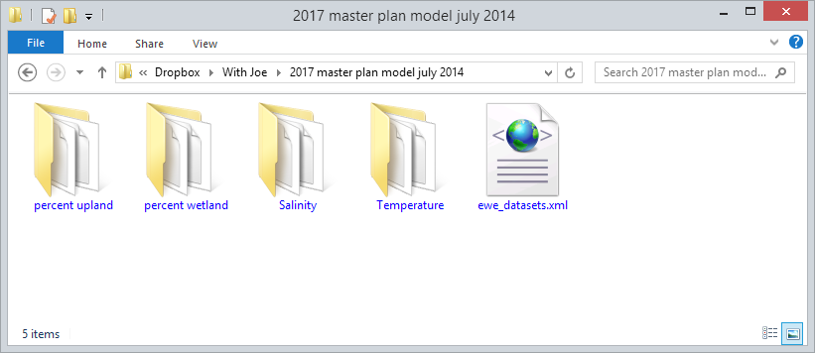
Figure 2.9 - Example contents of a data set export folder

Once the exported data sets are transferred to another computer they can used by EwE. For this, a user switches the local configuration to the exported data sets via the spatial temporal data page in the main EwE options interface (Figure 2.10). Ecospace now shows the data sets as usable for the model (Figure 2.11).

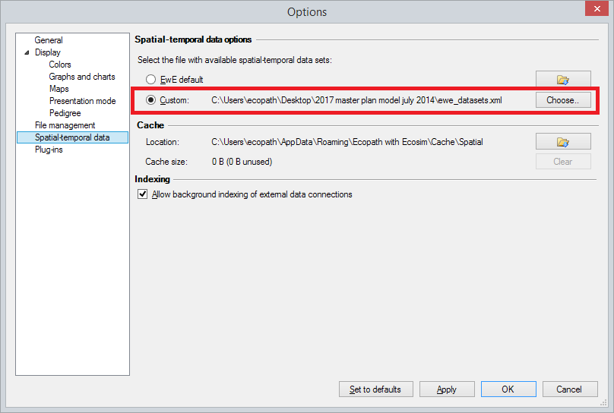
Figure 2.10 - Linking to a set of exported data sets that has been received from another user

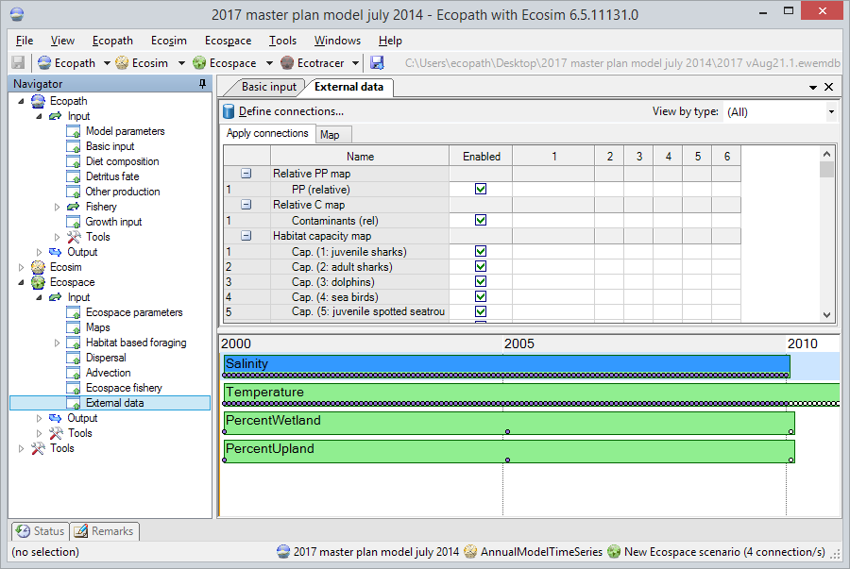
Figure 2.11 - The imported data sets displayed in Ecospace and ready to be used

2.4 Adding new ways to alter forcing and mediation functions
The Ecosim and Ecospace modules contain forcing functions and mediation functions through which temporal dynamics of the model can be influenced. These functions can be arbitrarily sketched, obtained from external data where known, or derived from a series of predefined mathematical distributions.
The predefined mathematical distributions already available in EwE did not contain shoulder and trapezoid distributions that would be needed for the 2017 Coastal Master Plan community model.

Changes to EwE
The EwE software now offers the predefined distributions illustrated in Figures 2.12 to 2.21. The shoulder and trapezoid distributions were added for Activity 2. In addition, efforts are under way to allow users to programmatically add their own distributions via plug-ins.

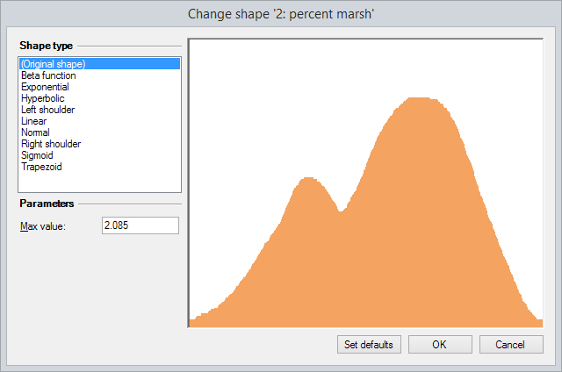  Figure 2.12 - Original contours | 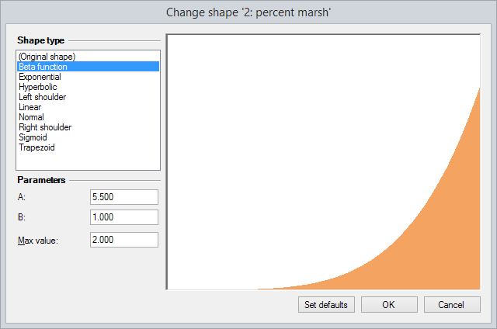  Figure 2.13 - BetaPDF distribution | 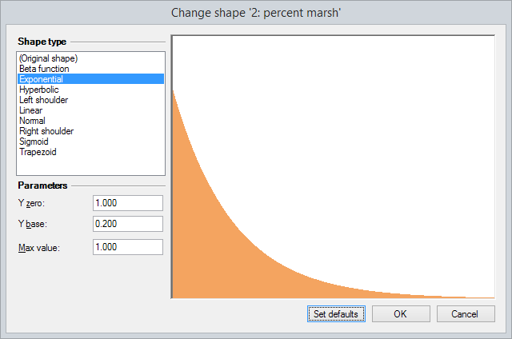  Figure 2.14 - Exponential distribution
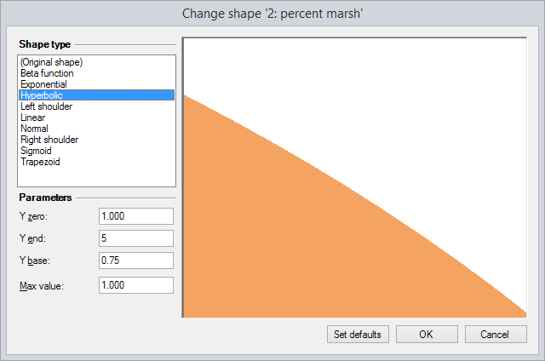  Figure 2.15 - Hyperbolic distribution | 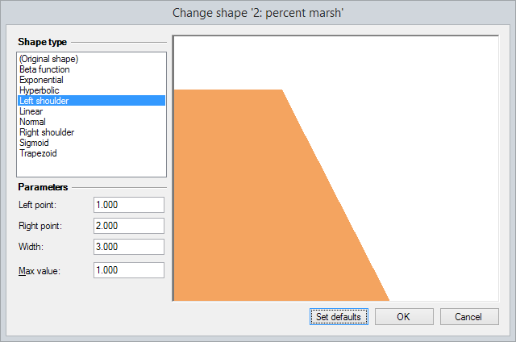  Figure 2.16 - Left shoulder distribution (newly added) | 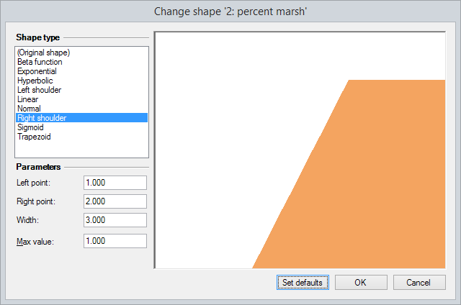  Figure 2.17 - Right shoulder distribution (newly added)
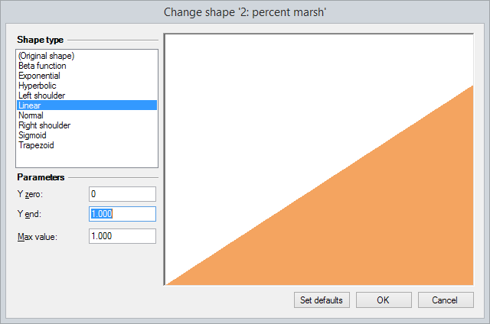  Figure 2.18 - Linear distribution | 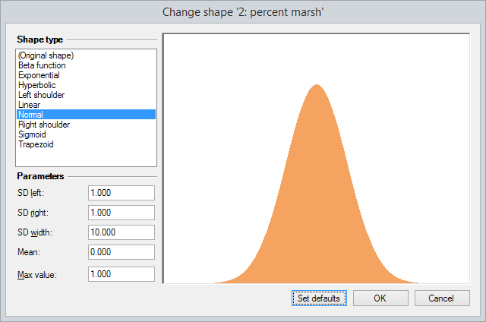  Figure 2.19 - Normal distribution | 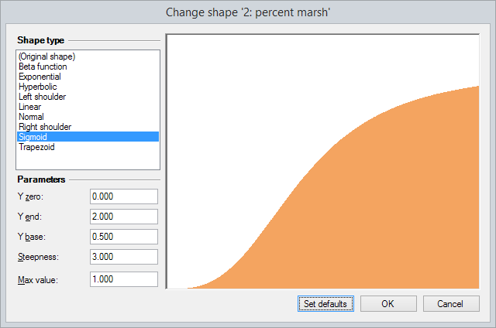  Figure 2.20 - Sigmoid distribution
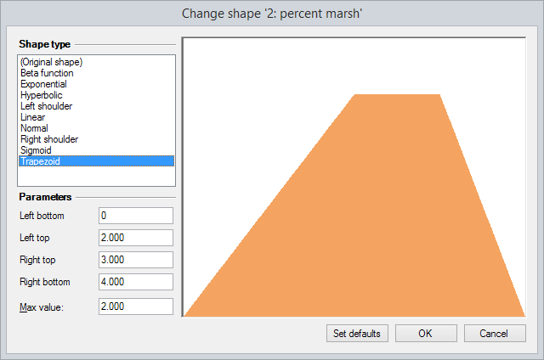
Figure 2.21 - Trapezoid distribution (newly added)

2.5 General improvements to EwE
The EwE software started to become sluggish in some aspects due to the large data demands for the 2017 Coastal Master Plan community model. Issues were addressed to improve performance of the software.

2.5.1 Changes to EwE
The following changes were made:
- Internal computations of the habitat capacity model were made to run faster.
- The drawing of Ecospace input maps has been sped up by selectively rendering information based on selected map layers.

